

SC3020 Database System Principles

Group 8

Name | Matriculation Number | Individual Contributions
BHATI NANCY | U2222368G | 20%
BRIAN TEY ZHI FONG | U2221714E | 20%
BUI KHANH HUNG | U2322190J | 20%
NYIM BOEY | U2320429D | 20%
SAM CHERN KAI, CHESTER | U2322722J | 20%

GENERATIVE AI TOOLS
Our group declares that no AI tools have been used in the report.

Section 1: Executing the file 3
Section 2: Storage Component (Task 1) 5
2.1 Structure Used 5
2.2 How the Page System Works 5
2.3 How the File is Parsed 6
2.4 Data Insertion into Pages During Parsing 6
2.5 How to Determine if Page is Full 7
2.6 Results 8
Section 3: Building B+ Tree (Task 2) 9
3.1 Structure Used 9
3.1.1 Feature 1: Records are kept in leaf level 10
3.1.2 Feature 2: Balanced Structure 10
3.1.3 Feature 3: Support for duplicates 10
3.1.4 Feature 4: Dynamic Growth and Shrinkage 10
3.2 Bulk Loading 11
3.3 Insertion into a Non-Full Node 12
3.4 Handling Overflow in Insertion 13
3.4.1 Root Node 13
3.4.2 Internal Node 13
3.4.3 Leaf Node 13
3.5 Results 14
Section 4: Executing Query (Task 3) 15
4.1 Structure Used 15
4.1.1 Purpose 15
4.1.2 Core data structures 15
4.2 How are Matches Being Found 15
4.2.1 Index Range Retrieval 15
4.2.2 Record Processing & Maintenance 16
4.2.3 Why it is Efficient 16
4.3 Deletion and Erasure 16
4.3.1 Deletion in Heap File 16
4.3.2 Deletion in B+ Tree 17
4.4 Results 18
4.4.1 Task 3 Statistics 18
4.4.2 Updated B+ Tree Stats (After Deletions) 19

Section 1: Executing the file
Launching Steps
Windows OS:
- Install cmake from cmake.org
- Launch Directory: cd Project_1
- Remove all past build directory: rm build
- Remove all files inside ./bin folder
- Create new build directory: mkdir build
- Generate Makefiles: cmake -S . -B build -G "Visual Studio 17 2022" -A x64
- Build File: cmake --build build --config Release
Mac OS:
- Install cmake from cmake.org
- Launch Directory: cd Project_1
- Remove all past build directory: rm -rf build
- Remove all files inside./bin folder
- Create new build directory: mkdir build
- Generate Makefiles: cmake -S . -B build
- Build File: cmake --build build --config Release
Output:
- Task 1 + Task 2 + Task 3:
.\build\Release\sc3020_task1.exe --load .\data\games.txt --db .\bin\games.db --build-index --delete --delete-threshold 0.9

- Optional: For point query
.\build\Release\sc3020_task1.exe --load .\data\games.txt --db .\bin\games.db --build-index --search 0.952

- Optional: For range query
.\build\Release\sc3020_task1.exe --load .\data\games.txt --db .\bin\games.db --build-index --range 0.8 1.0
Note: To run each output, build folder and files in ./bin folder must be deleted.

If any errors are encountered:
- rmdir build
- input “A” to delete everything
- delete files in ./bin folder

Output File Location:
- ./build folder populated.
- ./build/Release contains sc3020_task1.exe
- ./bin contains games.db, results_task123.txt

Section 2: Storage Component (Task 1)

2.1 Structure Used
We used a compact 39-bytes struct defined in record.hpp. It includes:
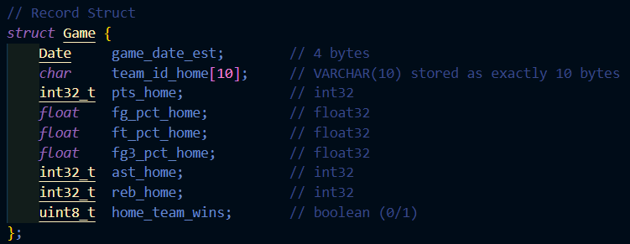
Data Fields | Data Type | Size(Bytes)
GAME_DATE_EST | Date | 4
TEAM_ID_home | Varchar(10) | 10
PTS_home | int32 | 4
FG_PCT_home | float32 | 4
FT_PCT_home | float32 | 4
FG3_PCT_home | float32 | 4
AST_home | int32 | 4
REB_home | int32 | 4
HOME_TEAM_WINS | boolean (0/1) | 1
Total bytes: 39 bytes
Supporting structs:
- RID: It identifies a record’s physical location i.e. blockId (page number), slotId (slot within the page) and pad (padding to make size 8 bytes)
- SlotEntry: It keeps track of the offsets and sizes of each record stored on the page, as well as flags to indicate if a slot is used or marked deleted.
- PageHeader: It contains metadata about each page like page ID, number of slots, directory end, and free space end.

2.2 How the Page System Works
Each page is 4096 bytes which includes:
- A PageHeader struct at the beginning (fixed size)
- A slot directory growing downwards (one SlotEntry per inserted record)
- Record data growing upwards from the end of the page
When a record is inserted:
- A SlotEntry is appended to the slot directory
- The actual record is copied to the free space from the back of the page
- The PageHeader is updated to reflect new dirEnd and freeEnd
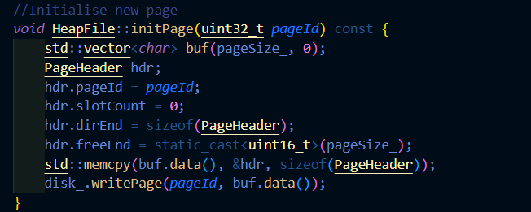

2.3 How the File is Parsed
The file is parsed using the Loader class:
- On construction, it opens the input file (.tsv, .csv, .txt) and reads the header.
- It automatically detects the delimiter (\t or ,)
- The header line is split into column names, and relevant column indices are stored
- Each subsequent line is read and split into columns
- Each field is trimmed and converted to the appropriate type (int, float, etc.)
- If parsing succeeds, a Game struct is populated and returned
Any malformed or incomplete rows are skipped, ensuring robustness.
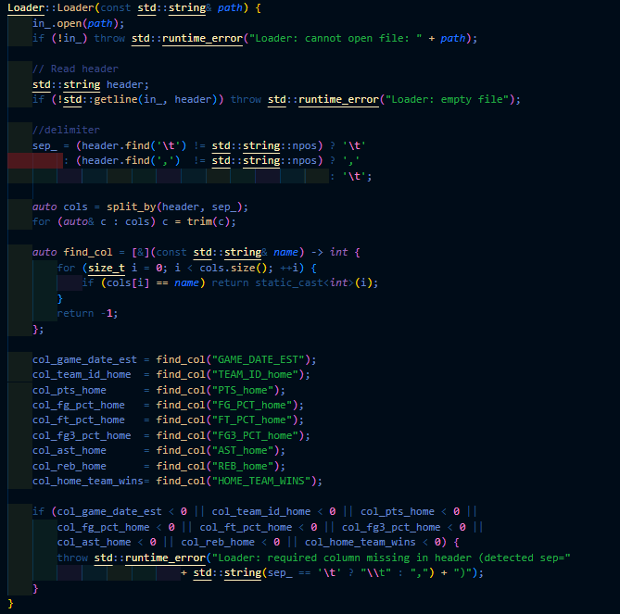

2.4 Data Insertion into Pages During Parsing
In the main.cpp file, data loading works like this:
- For each parsed Game record from Loader, heap.insert(game) is called
- HeapFile::insert():
  - Scans existing pages to check if there's enough space
  - If no page has room, a new page is allocated and initialized
  - Space is verified using ensureSpace(), which checks whether there's enough space to insert a new record
- Record is copied to the correct offset in the page's free space
- A SlotEntry is written into the slot directory
- Page header is updated

The result is a binary file (games.db) consisting of slotted pages, with compact and efficient storage of all parsed records

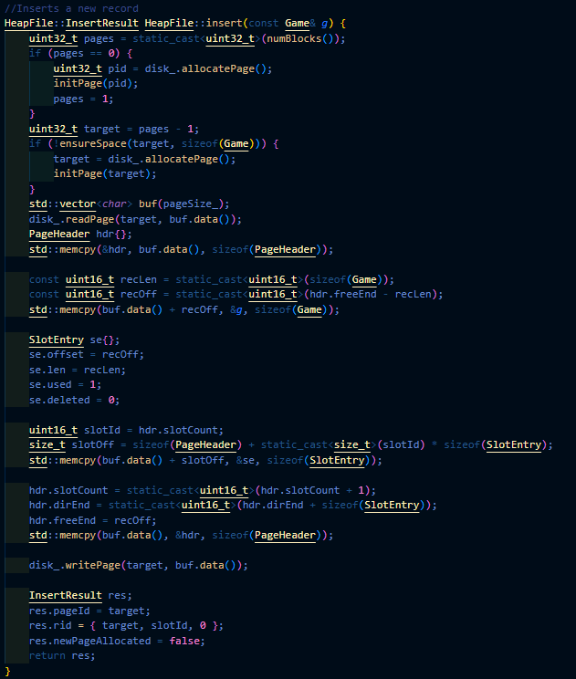

2.5 How to Determine if Page is Full
To determine if a page is full, the system checks whether there is enough space to insert both a record (fixed size: 39 bytes ) or a SlotEntry (metadata about the record). In memory, each page is organized with Header and SlotEntries growing downwards and Records growing upwards from the bottom. If these two regions collide, the page is full. This check is done using ensureSpace() function.

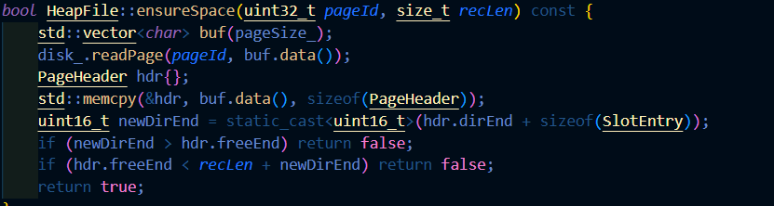

2.6 Results
Here is the output of task 1:
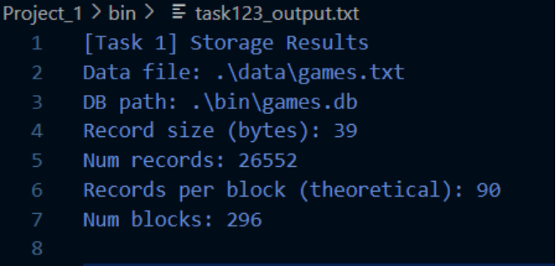
There are a total of 26552 records. The block size is 4096 bytes. With record size 39 bytes, Slot entry size 6 bytes and Pageheader size 8 bytes, there will $⌊\frac{4096-8}{39+6}⌋=⌊\frac{4088}{45}⌋ = 90$records per block. Therefore, to store all records in the database, we will need ⌈$\frac{26552}{90}$⌉ = 296 blocks.

Section 3: Building B+ Tree (Task 2)

3.1 Structure Used

To generate the structure to display the relevant information to be sorted according to FT_PCT_home, we adopted a B+ tree. It allows for the information to be efficiently searched, inserted and retrieved, while ensuring that all records are stored at the leaf level for fast range queries.
In the B+ tree, there are several attributes to take note of, which is being highlighted in Table 3.1.1.
Attributes | Definition
Keys | Shows the sorted list of FT_PCT_home in ascending order.
Pointers | To point to the correct records / next leaf node.
n | Value of n to determine the number of keys and pointers.
Table 3.1.1: Illustration of the Key attributes in a B+ Tree.

From the first experiment, we can observe that there are 371 distinct FT_PCT_home. Based on this value, our team has decided to fix our value n to be at 30 instead. This implies that the maximum number of keys per node will be 30. Each internal node will also be able to direct query up to 31 subtrees while storing 30 distinct FT_PCT_home values.

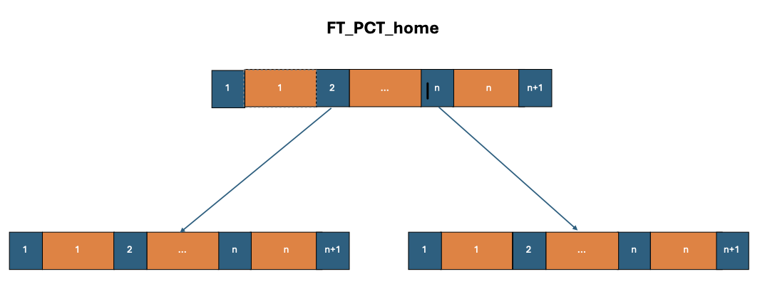
Figure 3.1.1: This figure illustrates how the B+ Tree will look like.

From the above Figure 3.1.1 illustrated, several key features can be observed.

3.1.1 Feature 1: Records are kept in leaf level
A key feature of a B+ Tree allows all records to only be kept at the leaf level. This helps to ensure uniform search paths and all queries to be straightforward.
As for the internal nodes, they are focussed on storing keys and corresponding routing pointers.

3.1.2 Feature 2: Balanced Structure
B+ Tree also helps to ensure a well balanced structure where all leaves appear to be the same depth.
As a result, we can see that search, insert and delete operations are predictable O(log n) complexity.

3.1.3 Feature 3: Support for duplicates
Multiple TEAM_ID_home can share the same FT_PCT_home. In our code implementation, each leaf entry stores a vector of RIDs to capture all rows with the same FT_PCT_home value.

3.1.4 Feature 4: Dynamic Growth and Shrinkage
Another big key feature of a B+ Tree allows for nodes to be able to merge and split when the nodes are full and under-utilized respectively. As such, indexes in B+ Tree can adjust dynamically to insert and delete without a full reorganization.

3.2 Bulk Loading
In the lecture slides, we understand that there are mainly two methods in order to create a B+ tree using the existing collection of data.
Method 1: Repeatedly inserting data
Method 2: Bulk Loading
It is observed and understood that Method 2 is much more efficient and less time consuming compared to Method 1. In Method 1, inserting one key at a time will result in repeatedly splitting nodes and rebalancing, which will recursively call for many iterations of checking, which is often an inefficient method.
On the other hand, Method 2 applies a bottom-up bulk-loading algorithm that achieves a compact tree with optimal fill. The following steps are adopted to ensure that bulk loading of data is done successfully.
More will be shared about the steps to achieve this fill.

Steps | Description
1 | We first group all the data with duplicate keys FT_PCT_home. This ensures that all (FT_PCT_home, RID) are combined into a single (key, vector<RID>) entry. By doing this, we reduce the number of indexed entries from 26,552 to 371 distinct values.
2 | Next, we have to pack the entries so that they can form the leaf nodes. By using the predefined value of n to be 30, we can deduce that 371 keys will require minimally 13 leaf blocks.
3 | With all the leaf blocks, they can be grouped to form the parent node. Each parent node will be filled with (n+1) children.  This process will be iteratively performed until we can finally have 1 root node remaining.

From the data we have on hand, we can understand that the 14 leaf blocks can be grouped to form a single parent node as only 14 pointers will be required. As such, we can observe that our B+ tree will only be 2 levels tall after mass bulk loading of data as illustrated in Figure 3.2.1.

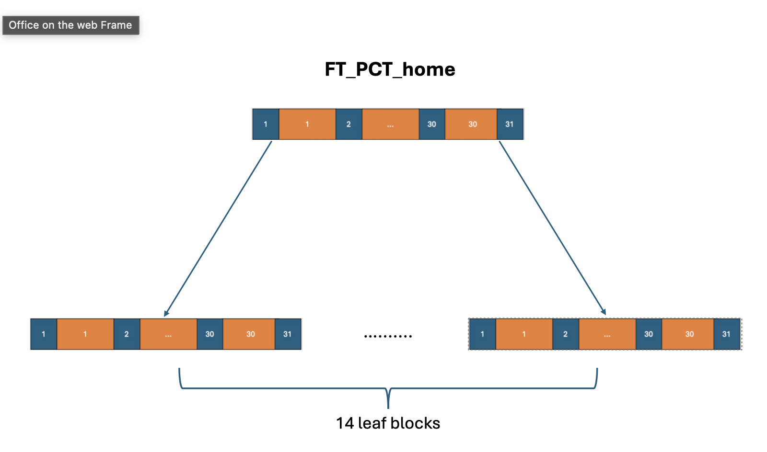
Figure 3.2.1: Illustration of the B+ Tree

3.3 Insertion into a Non-Full Node
In order to insert new data into the B+ tree, we first need to check whether the root node is full. This is necessary as if the root is already full and we descend without splitting, a split at the leaf node could force a key to be promoted into a root that has no room. This requires backtracking and restructuring which complicates the process. Thus, it is a key rule for B+ tree insertion where the algorithm works top-down; it ensures that the root is never full before insertion begins, and further splits full children nodes during descent. This guarantees that the leaf node where the new key is to be inserted always has space available and avoids upward recursive splits.

Assuming that the leaf node is non-full when inserting a key, we find the correct position of the key by using binary search to find the first position where the key can be inserted without breaking sorted order. If the key already exists, the new RID is appended to that key’s bucket. Otherwise, the key and its RID are inserted in sorted order into the leaf node.

3.4 Handling Overflow in Insertion
When inserting into a B+ tree, if the target node is already full, meaning it contains the maximum number of keys equal to the tree’s order n, an overflow occurs. In general, we divide the node into two and promote a separator key to the parent node. At each internal node, before descending, the algorithm checks if the child is full. If so, it splits the child and then descends. This ensures we never recurse into a full node. This runs recursively until we reach the leaf node, which is guaranteed to be non-full as we would have already split it. The key can then be safely inserted. Depending on what type of node is full, we will execute different steps as shown in the following elaboration.

3.4.1 Root Node
Since a root node is the only node without a parent, its overflows must be handled specially.
When the root overflows:
- A new root node is created.
- The old root node is split into two child nodes.
- The separator key is inserted into the new root node.
This increases the tree’s height by 1 and ensures that the B+ tree remains balanced.

3.4.2 Internal Node
Internal nodes are nodes between the first and last levels of the tree.
Assuming that the parent node is non-full, if an internal node overflows:
- The node is split around its median key.
- The keys left of the median stay in the original node and the keys to the right of the median are passed to a new internal node.
- The child pointers are redistributed accordingly.
- The median key itself is promoted into the parent node.
- The parent will also have its pointers redistributed accordingly so that the new internal node is responsible for the right half of the original children.

3.4.3 Leaf Node
Leaf nodes are at the bottom-most layer of the tree, where keys are to be inserted directly.
Assuming that the parent node is non-full, if a leaf node overflows:
- It is split into two leaf nodes, with roughly half the keys in each.
- The first key of the new right leaf is promoted into the parent node as the separator.
- The leaf-level “next” pointer is updated to maintain the linked list of leaves. This ensures that range queries still function correctly across the leaf level.

3.5 Results
Based on the data obtained from the first task, we can observe that there are 371 distinct keys. As such, we ran a simulation to deduce the best tree with different values of n. The results can be illustrated by the following table 3.5.1.

n value | 3 | 7 | 10 | 15 | 20 | 25 | 30
B+ Tree Level | 5 | 3 | 3 | 3 | 2 | 2 | 2
Num of Nodes | 165 | 61 | 42 | 28 | 20 | 16 | 14
Table 3.5.1: Corresponding Levels and Number of nodes for each respective n value.

With the above results shown, we ultimately decided on setting the value of n to be the value 30. Below are the results we obtained for task 2 using n=30.

B+ Tree Levels : | 2
Number of Nodes: | 14
Root Key Values: | [0.433, 0.52, 0.567, 0.614, 0.653, 0.703, 0.741, 0.784, 0.828, 0.871, 0.915, 0.966]
Table 3.5.2: Results from choosing n to be 30.

Moreover, here are some benefits from using setting the value of n to be 30.
Advantage 1: Shallow Tree Height of 2 results in lower I/O cost and faster searches with just
a level of 2.
Advantage 2: Compact Index size of 14 allows for minimal storage overhead
Advantage 3: Scalability margin is available as the root can support up to 31 children and
only 13 are used currently, which shows that there is plenty of room to expand.

Section 4: Executing Query (Task 3)

4.1 Structure Used

4.1.1 Purpose
- Support queries of the form FT_PCT_home > T and return matching rows, then delete them while keeping the heap file and B+-tree consistent.

4.1.2 Core data structures
- Storage & IDs: We still operate on the same slotted-page heap file; qualifying rows are addressed by RID = {blockID, slotID}.
- Index: In-memory B+-tree over key FT_PCT_home (float), order n = 30, leaves linked via next. Duplicate keys map to vector<RID> in each leaf slot.
- Range retrieval handle: RangeCollect(low, high) returns (key, RID) pairs and indexNodesAccessed (count of index nodes visited during retrieval).
- Instrumentation:
  - index nodes accessed (retrieval)
  - distinct data blocks touched (when deletions are applied)
  - number deleted & average deleted key
  - index retrieval time vs brute-force time/blocks.

4.2 How are Matches Being Found

4.2.1 Index Range Retrieval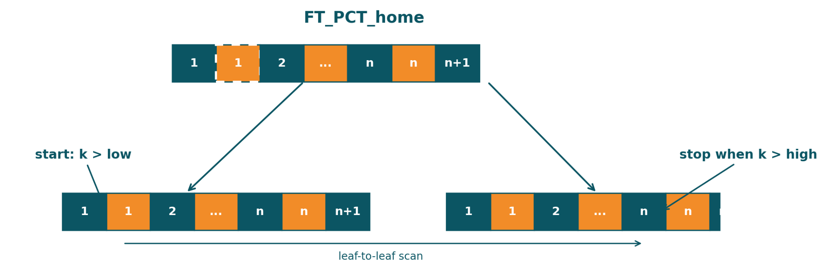
- Descend to the start leaf. From the root, binary-search separator keys using the lower bound low to reach the first candidate leaf. Count each internal node visited and the first leaf in indexNodesAccessed.
- Scan along the leaf chain. Follow leaf → next, visiting keys in order:
  - Select: emit every (k, RID) where k > low && k < high.
  - Early stop: once k is greater than high, terminate (skipped when high = +∞).
  - Duplicates: for a qualifying key k, output all RIDs in its RID vector.
  - Accounting: increment indexNodesAccessed for each subsequent leaf we step into.
- T-only queries: implement strict > T by calling RangeCollect(T, +∞).
- Cost: O(h+L) — where h is the tree height (≈ 2 with n=30) and L is the number of leaf nodes scanned until early stop.

4.2.2 Retrieval outputs & counters
- Output shape: a stream (or vector) of (key, RID) pairs in non-decreasing key order.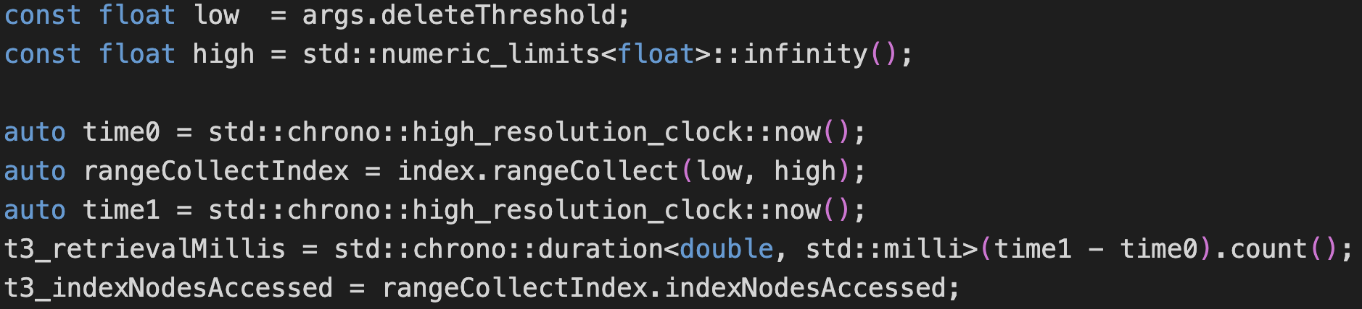
- Instrumentation (retrieval-only): record indexNodesAccessed and the index retrieval time.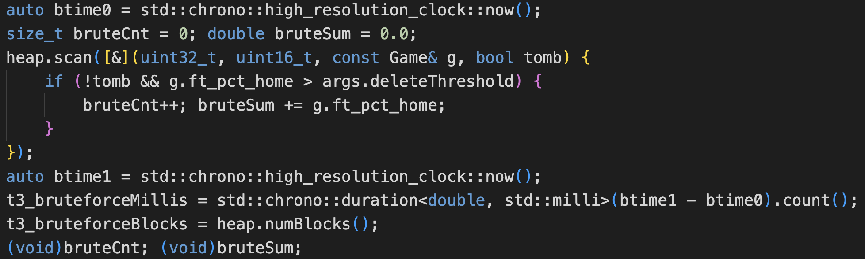
- Baseline comparison: optionally run a full heap scan with the same predicate to compare brute-force time/blocks

4.3 Deletion and Erasure

4.3.1 Deletion in Heap File
As deletion is done in a heap file, there is no physical modification on the data. Instead, a ‘deleted’ flag is used to indicate that the record has been logically deleted.
- Each record resides in a page, and its location is tracked by a slot entry containing offset, length and status bits.
- When a deletion is requested, the code invokes HeapFile::markDeleted(const RID& rid).
- The function then reads the slot entry for the given RID and sets the deleted flag to 1.
- The data bytes of the record remain in the page but are no longer considered valid.
This design avoids expensive in-place compaction of data and ensures that other references to the page remain valid. It is fast, requiring only a slot directory update and avoids rewriting the page structure.

4.3.2 Deletion in B+ Tree
The B+ tree also enforces the deletions to maintain query correctedness. This is being handled by BPlusTree::erase() and its helper functions as below.
- BPlusTree::eraseRecursive( ),
- BPlusTree::borrowFromLeft( ),
- BPlusTree::borrowFromRight( ),
- BPlusTree::mergeNodes( )
Process:
- Locate the key:
  - The algorithm will go down the tree using key comparisons until the relevant leaf node has been reached
  - If the key is present, the associated vector of RIDs is accessed
- Remove the RID:
  - Within the lead, the specific RID is removed from the vector
  - If there exists other RIDs under the same key, the key stays in the leaf
- Remove the key if empty:
  - If the RID vector becomes empty, the key is erased from the leaf node entirely
- Rebalancing the B+ Tree:
- If the deletion cause the node to fall below the minimum occupancy, the algorithm restores balance by either
  - Borrowing from a sibling. The algorithm checks the left sibling first then the right sibling and then updates the parent separator.
  - Merging with a sibling. When borrowing from a sibling is not possible, it merges with a sibling node and the parent’s node separator key is removed.
- Root adjustment:
  - If the root becomes empty after a merge, its single child becomes the new root, and reduces the tree height as a result.

4.4 Results

4.4.1 Task 3 Statistics
Index Nodes Accessed | 4
Data Blocks Accessed | 293
Number of Games Deleted | 1778
Avg FT_PCT_home (deleted) | 0.939643
Retrieval Time (ms) | 0.0631
Brute-force Blocks Accessed | 296
Brute-force Time (ms) | 4.7587

Explanation:
- B+ Tree method scanned 3 blocks less than brute force method, which meant that for FT_PCT_home > 0.9, there are 293 blocks that contain FT_PCT_home with values larger than 0.9 and 2 blocks without any FT_PCT_home with values larger than 0.9.
- Brute force takes much longer as it has to scan through the heap file one by one while B+ tree makes use of the index to speed up access time

4.4.2 Updated B+ Tree Stats (After Deletions)
Levels | 2
Nodes | 12
Root Keys | 0.433, 0.52, 0.567, 0.614, 0.653, 0.703, 0.741, 0.784, 0.828, 0.871

Explanation:
- The number of levels are the same, which means that there are insufficient deletions that will cause the level of the tree to decrease.
- There are 2 nodes less as compared to non-deleted dataset.
- After deletion, root keys that are larger than 0.9 are removed due to rebalancing. This also corresponds to the 2 nodes deleted.

